Wyatt Dawn Heleos II Short Instructions

Initializing:

Connect the instrument as well as your computer to the Ethernet switch and turn on both.
Run the software “ASTRA 6.0” and check if the Light Scattering device Dawn Heleos II is connected by clicking “System” → “Instruments” after the initialization of the instrument.

Cleaning:

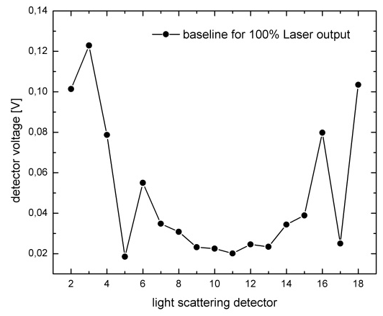
In order to ensure proper measurements the device has to be cleaned through rinsing with dH₂O (Millipore Water). In case of greater impurification a mixture of ethanol and dH₂O can be used as well as air bubbles for cleaning of the sample cell. Never use other liquids than dH₂O or ethanol for cleaning! Please approach the local contact for cleaning issues.
Before running a measurement a stable baseline should be set by rinsing the Instrument with dH₂O through a 0.02 µm Filter. For adjusting the baseline choose “batch” at the instruments touch display to see all detector voltages. The baseline should not vary more than 0.1V for all detectors for several minutes (see figure).
Please remember to rinse the instrument after each experiment and prevent the sample cell from drying out.

Running an experiment:

- Once the Instrument is visible via the Software on your Computer and a baseline is set choose: File→New→Experiment. The Experiment can then be started “From Method”, if there is a suiting method present (i.e. “Batch Debye Plot”). Otherwise choose “From Default”.

- Save the Experiment and choose a desired file name to keep track of your experiments.
- In the Configuration Tab the Calibration Constant should be set to 4.239 e⁻⁵. Other values like operating wavelength should already be chosen by the software after connection with the instrument. These values can be found in the instrument specification on the MLZ-webpage.
- Now the solvent and the sample should be characterized. Some solvents are already in the database. Verify at least refractive index and viscosity of the used solvent and concentration of the sample. When entering the value for dn/dc of the sample, the software is able to evaluate the particle size.
- In the “Procedures” tab choose “Basic collection” and set the measurement “Duration ” in minutes. Enter a longer time than your measurement will take because the measurement can be stopped at any time by the user. Also remember that setting a baseline at the beginning and the end of each measurement will take some time too.

- On the Instrument Touch-screen the laser power can be adjusted (from 10 to 100%) as well as Temperature.
Hint: The measurement time as well as the laser power can be changed during the experiment, the software will recalculate the recorded data in case of a change of the laser power.
- Save the experiment and start the measurement by clicking the “Run” icon on top of the software interface. The Software will probably remember you of missing variables like dn/dc but you may still start the measurement.

- After the measurement is done, set a baseline and stop data recording by clicking the “Stop” icon , otherwise the software will end the measurement after the adjusted measurement time is over.

- In the “Procedures” tab choose “baseline” and set the recorded baseline for data evaluation or click “auto find baselines”.

- In the “Procedures” tab choose “Peaks”, where you can mark certain data ranges of interest for further data treatment. We refer to the user-guide for further data treatment (i.e. molar mass evaluation) which can be found in the procedures tab.

- An overview of the measurement can be found in the “Reports” tab.
Data export:

- Choose Experiment→Graph→Add Custom Plot. Here you can choose how you want the data to be displayed. Do this i.e. for “raw data” and for data in “physical units”.

- Click File→Export and choose a folder where the file is saved. Choose the export format and the type of data (i.e. raw data or physical units).
Normalization Procedure:

In order to create static light scattering curves the collected data has to be normalized. For different solvents new normalization coefficients have to be evaluated.

- Prepare a sample of particles with a known particle size and the solvent of interest. The particle size should be about 20 nm or smaller, but you can also use larger particles. However the larger the particle size for normalization, the greater the error of the coefficients.

- Perform a measurement with this sample as described above.

- In the “Procedures” tab choose “Peaks” and set a peak for a stable set of data points.

- Choose Experiment→Configuration→Normalize. Enter the Peak name as well as the radius of the used particles and click “Normalize”. The software then calculates the normalization coefficients for each detector related to the 90° detector signal (detector 11), whose coefficient is set to 1.
Remember to rinse the instrument after each experiment and prevent the sample cell from drying out.

